21. Write a program to print the following pattern ?

import java.util.\*;

public class patternpercentage

{

public static void main(String[] args)

{

Scanner s= new Scanner(System.in);

int i,j,c,count=0,cc=0;

System.out.println("enter number of rows:");

int n=s.nextInt();

for(i=1;i<=n;i++)

{

for(j=1;j<=i;j++)

{

System.out.print("%");

}

System.out.println();

}

}

}

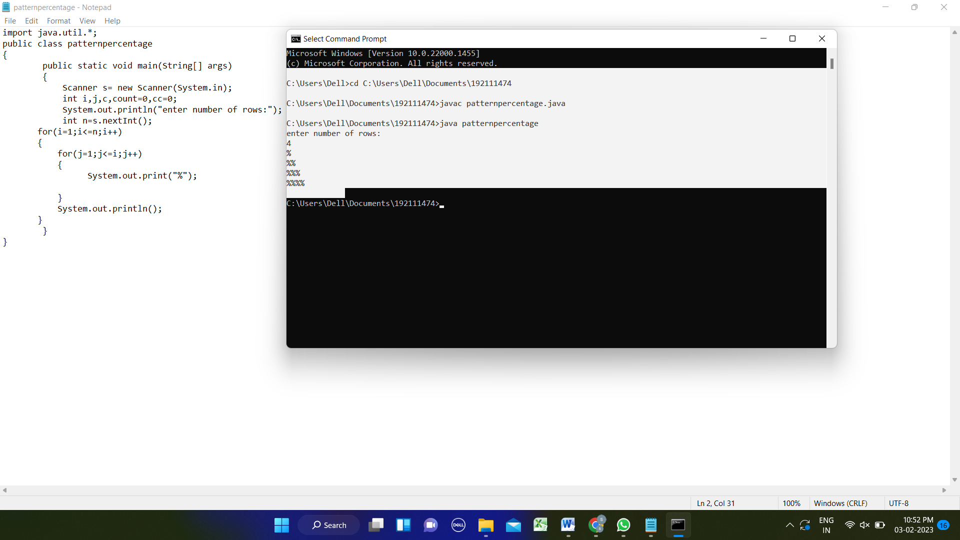

22. Write a program using function to calculate the simple interest. Suppose the customer is a senior citizen. He is being offered 12 percent rate of interest; for all other customers, the ROI is 10 percent.

import java.util.\*;

class calculate

{

void interest(int p,int t,int r)

{

System.out.println((p\*t\*r)/100);

}

}

class Main

{

public static void main(String [] args)

{

Scanner sc=new Scanner(System.in);

System.out.println("enter the principal amount and time:");

int p=sc.nextInt();

int t= sc.nextInt();

int r;

calculate c=new calculate();

System.out.println("is the customer senior citizen(y/n):");

char cu=sc.next().charAt(0);

if(cu=='y')

{

r=12;

System.out.println("simple interest:");

c.interest(p,t,r);

}

else

{

r=10;

System.out.println("simple interest:");

c.interest(p,t,r);

}

}

}

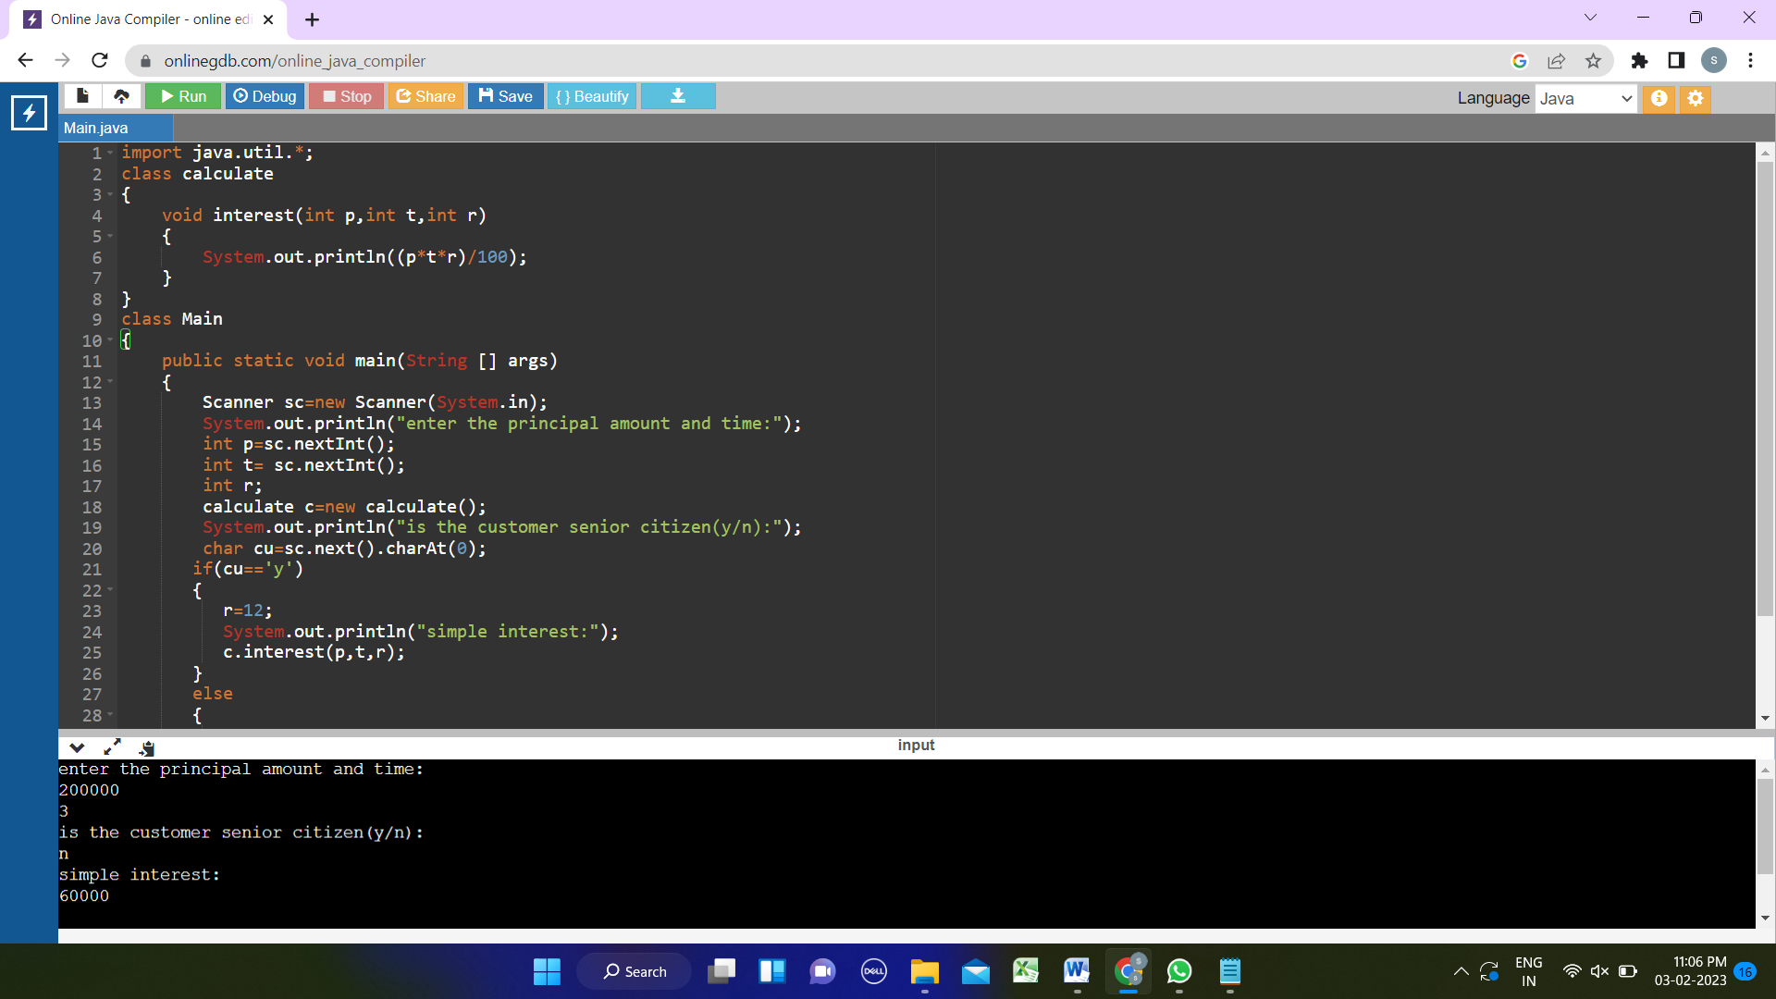

23. Write a program to print the Fibonacci series.

import java.util.\*;

class fibonacciseries

{

public static void main(String[] args)

{

Scanner sc=new Scanner(System.in);

System.out.println("enter the number of terms:");

int n=sc.nextInt();

int a=0,b=1,c;

System.out.println("fibonacci series:");

System.out.print("0\t1\t");

for(int i=1;i<=n-2;i++)

{

c=a+b;

a=b;

b=c;

System.out.print(c+"\t"); }

} }

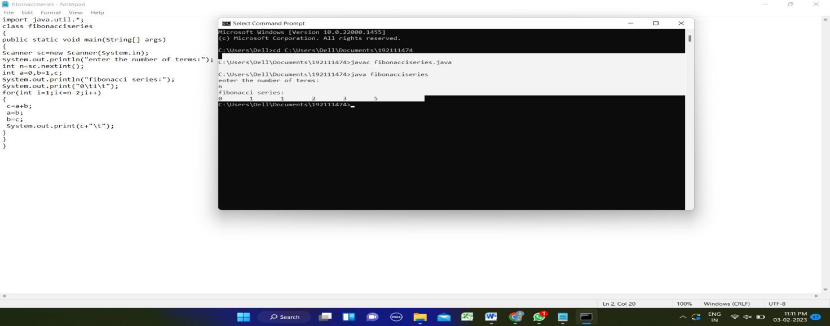

24.Write a program to print the numbers from M to N by skipping K numbers in between?

import java.util.\*;

class skippingnuminrange

{

public static void main(String[] args)

{

Scanner sc=new Scanner(System.in);

System.out.println("enter the first and last terms:");

int a=sc.nextInt();

int b=sc.nextInt();

System.out.println("enter number of terms to be skipped:");

int k=sc.nextInt();

for(int i=a;i<=b;i++)

{

System.out.print(i+" ");

i=i+k;

}

}

}

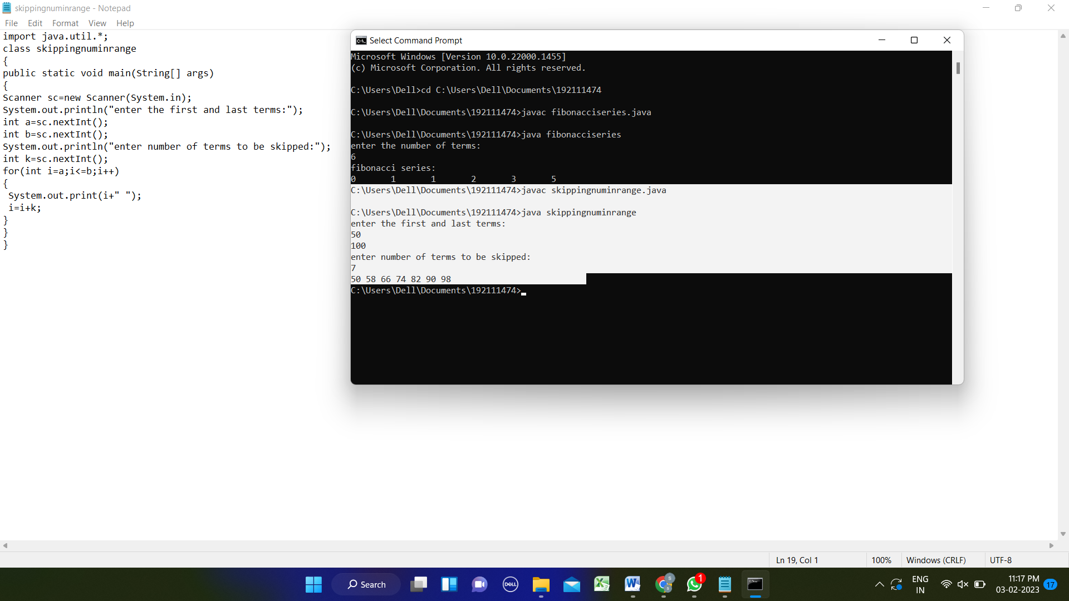

1. 25. Write a program to print all the composite numbers between a and b?

Sample Input:

A = 12

B = 19

Sample Output

14, 15, 16, 18

import java.util.\*;

class composite

{

public static void main(String [] args)

{

Scanner sc=new Scanner(System.in);

System.out.println("enter the first and last terms:");

int a=sc.nextInt();

int b= sc.nextInt();

int i,j,count=0;

System.out.println("composite numbers between "+a+" and "+b+" is:");

for(i=a;i<b;i++)

{

for(j=1;j<=i;j++)

{

if(i%j==0)

{

count=count+1;

}

}

if(count>2)

{

System.out.print(" "+i);

}

}

}

}

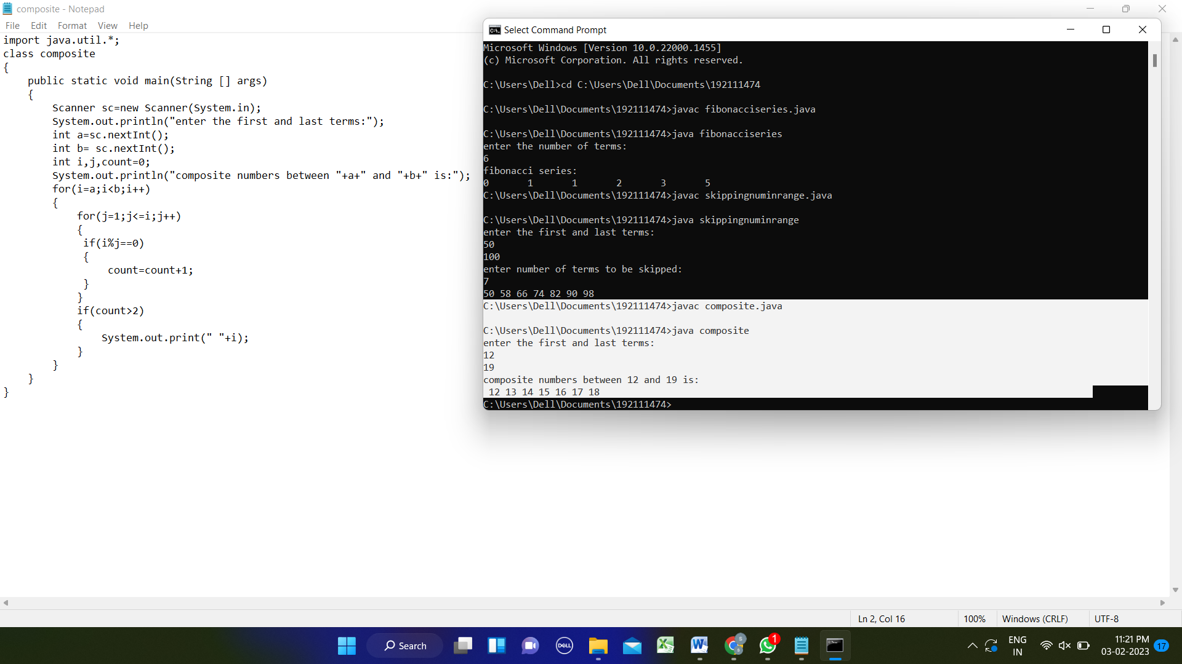

26. Write a program to given a fixed-length integer array arr, duplicate each occurrence of zero, shifting the remaining elements to the right.

import java.util.\*;

class duplicatezero

{

public static void main(String [] args)

{

Scanner sc=new Scanner(System.in);

System.out.println("enter the number of elements in array:");

int n= sc.nextInt();

int a[]=new int[n+1];

int i,j;

System.out.println("enter the elements of array:");

for(i=0;i<n;i++)

{

a[i]=sc.nextInt();

}

for(i=0;i<n;i++)

{

if(a[i]==0)

{

for(j=n-1;j>=i;j--)

{

a[j+1]=a[j];

}

}

i=i+1;

}

System.out.println("after duplication the elements of array:");

for(i=0;i<n;i++)

{

System.out.print(" "+a[i]);

}

}

}

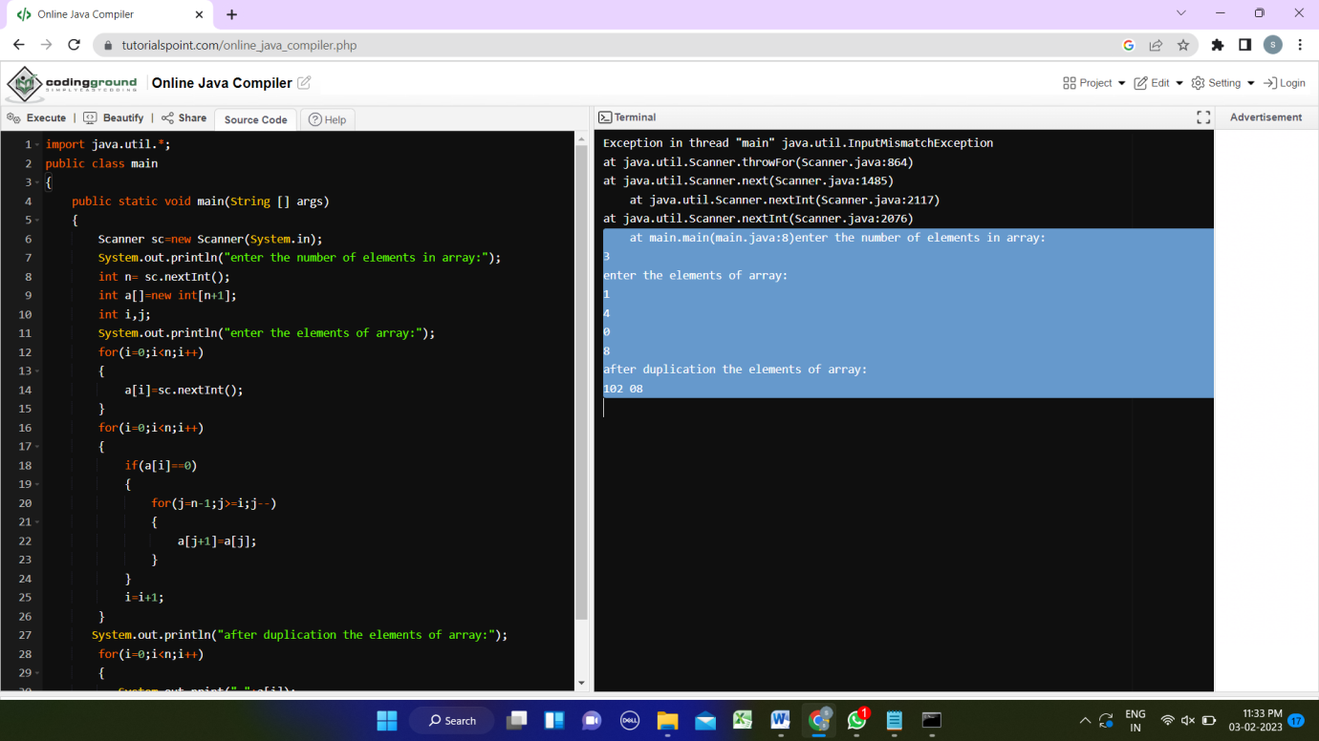

27. Write a program that accepts a string from user and displays the same string after removing vowels from it.

Sample Input & Output:

Enter a string: we can play the game

The string without vowels is: w cn ply thgm

import java.util.\*;

class removingvowels

{

public static void main(String[] args)

{

Scanner s=new Scanner(System.in);

System.out.println("enter the string:");

String str=s.nextLine();

char c=' ';

int count=0;

for(int i=0;i<str.length();i++)

{

c=str.charAt(i);

if(c=='a'||c=='e'||c=='i'||c=='o'||c=='u'||c=='A'||c=='E'||c=='I'||c=='O'||c=='U')

{

System.out.print(" ");

}

else

{

System.out.print(c);

}

}

}

}

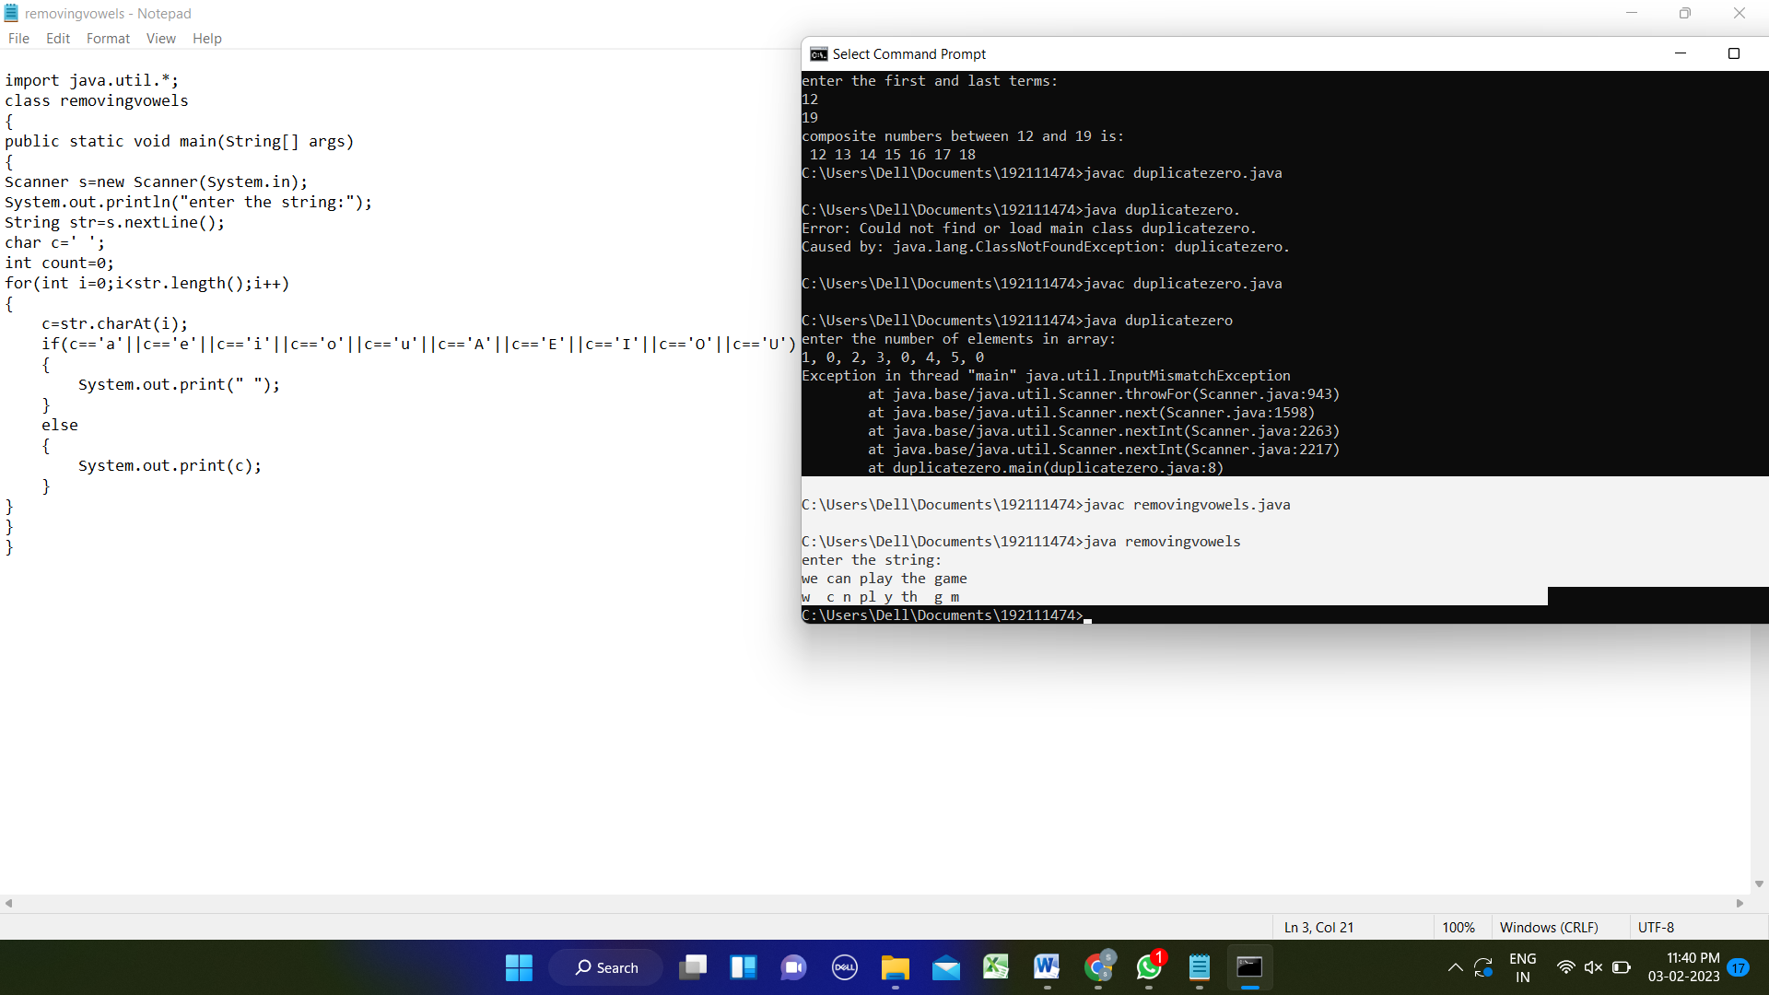

28.pritnt a program for right triangle with star pattern ?

import java.util.\*;

public class Main

{

public static void main(String[] args)

{

Scanner s= new Scanner(System.in);

int i,j,c,count=0,cc=0;

System.out.println("enter number of rows:");

int n=s.nextInt();

for(i=1;i<=n;i++)

{

for(j=n;j>i;j--)

{

System.out.print(" ");

}

for(c=1;c<=i;c++)

{

System.out.print(" \*");

}

System.out.println() } } }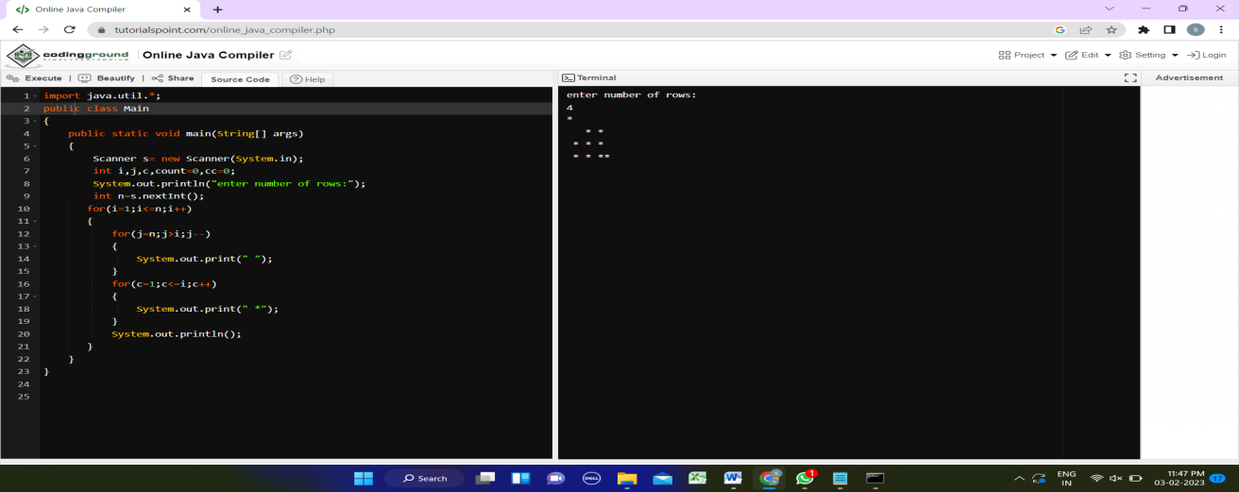

29. write a profram tp print the inverted full pyramid ?

import java.util.\*;

public class Main

{

public static void main(String[] args)

{

Scanner s= new Scanner(System.in);

int i,j,c,count=0,cc=0;

System.out.println("enter number of rows:");

int n=s.nextInt();

for(i=1;i<=n;i++)

{

for(j=1;j<=i;j++)

{

System.out.print(" ");

}

for(c=n;c>=i;c--)

{

System.out.print(" \*");

}

System.out.println(); } } }

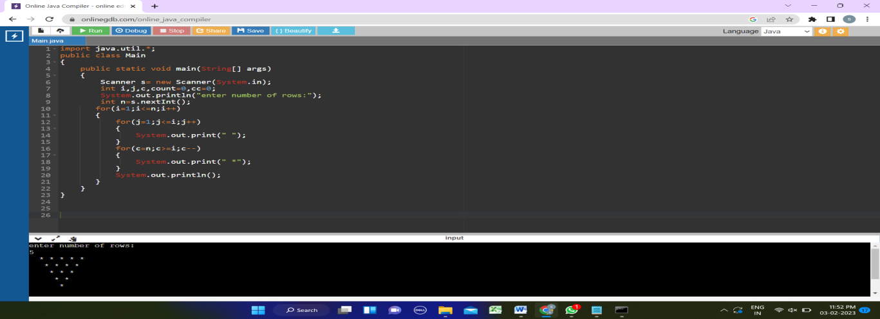

30.write a program to print thre numner if factors and nth factor ?

import java.util.\*;

public class Main

{

public static void main(String[] args)

{

int num,n;

Scanner sc = new Scanner(System.in);

System.out.print("Enter a number : ");

num = sc.nextInt();

System.out.println("Enter N:");

n= sc.nextInt();

int i, count = 0;

for(i = 1; i <= num; i++)

{

if(num % i == 0)

{

count = count + 1;

if(count==n)

{

System.out.println(n+" Factor is "+i);

}

}

}

System.out.print("\nTotal factors of " + num + " : " + count);

}

}

